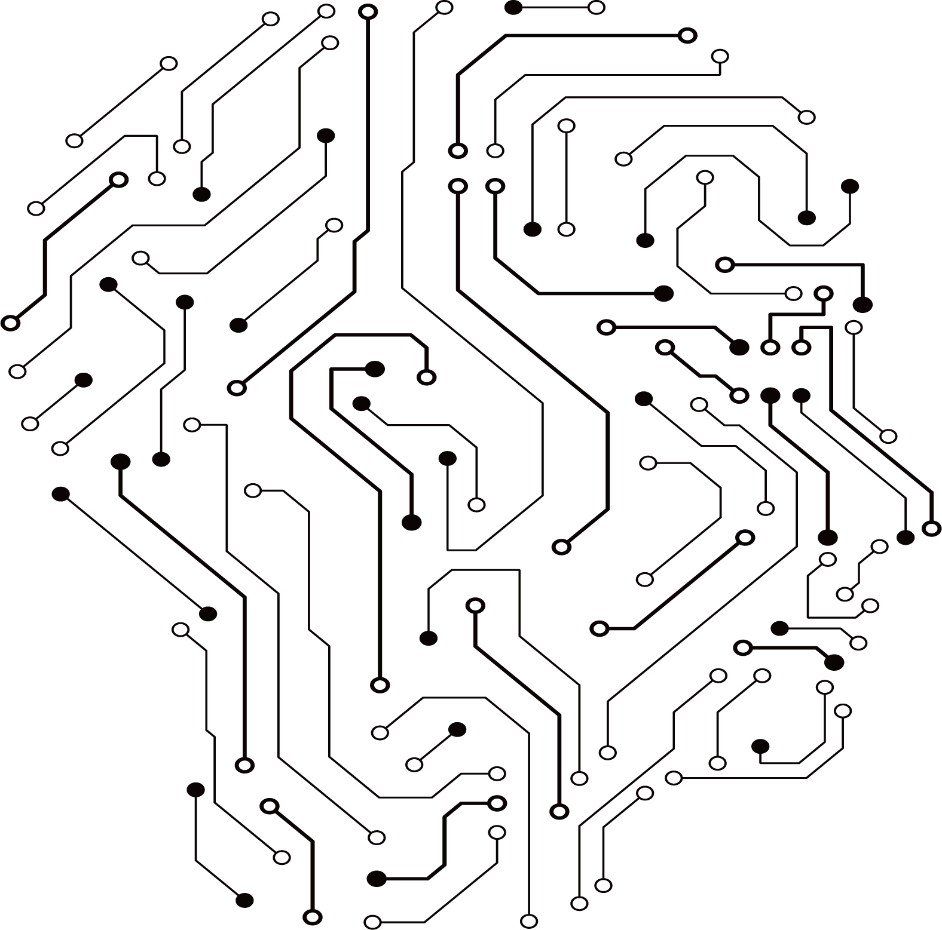

Module: Electric Circuits

Module code: 20ELEC01C

Module Leader: Dr. Rania Swief

First Year Computer Engineering

Manar Akram 195060

Omar Mohamed Saad 195606

Ahmad Mokhtar 187377

Muhammad Farid 194308

**2021**

12v and 5v Dual Power Supply



Contents

List of figures …………………………………………………….……………….…………..2

Abstract ……………………………………………………………………………….………3

Introduction ………………………………………………………………………….………..4

Theoretical Background ...………..…...…...………………………………………………….5

AC, DC, and diodes .…..………..………………………………………………………….5

Capacitors ……………………....……………………………………………………….....5

Transformers ….………………..………………………………………………………….5

Integrated Circuits and Voltage Regulators….………………………………………….....6

Practical Installation ...………………………………………………………………...………7

Results ……………………………..……………………………………………….……...….9

References …………………………………………………………………………………...11

List of figures

Figure 1. bridge rectifier output ……………………………………………………...……….5

Figure 2. Electrical Transformer……………..………………………………………………..6

Figure 3. 5v and 12v circuit schematics.………………………………………………………7

Figure 4. the physical circuit on the breadboard with parts number………………………......8

Figure 5. circuit on the breadboard ...………..………………………………………………..9

Figure 6. 5v output ……………..……………………………………………………………..9

Figure 7. 12v output ……………..………………………………………………………..…..9

Abstract

This report aims to show the steps of budling a dual power supply that output two positive values of a 12 voltage and a 5 voltage by using voltage regulator, then show its circuits, components and its usage. This report talks about power supply and its important because power supplies in as important eclectic device because it can be found in many other electric devices such as cameras, phones, mp3 plays, and many other electric devises if not most of them, power supplies are so important to the point that there is power supplies engineers whom their main and only focus is to develop power supplies or create new ones that are much smaller, lighter, generate less heat and more power [2].

Introduction

Electric power is the ratio between time and the transition of electric energy by a circuit, and power supply is an electronic gadget that provisions eclectic capacity to an electric load, in other words, the main job for the power supply is to convert the current from the source the wanted voltage, current, and frequency to the load [3].

Power supplies can provide a positive or a negative output voltage by controlling the energy passed to the load through a voltage called the error voltage, the positive output voltage means the power supply needs to pass more energy to the output because the output is too low, but the negative output means the energy that passes should be reduced and the output is too high [1]. Dual power supplies can output two voltage values, it can output the same voltage in a negative and positive value, such as -12v and +12v, or it can output two different voltage values, such as 5v and 12v.

The early 1920s was when power supplies first start to develop, first when crude devices were built to power radios. In the early 1930s, most radios were already using built-in power supplies, after that in the 1940s, power supplies started using vacuum tubes as both power and a controlling element. Voltage regulators were the predecessor for nowadays Zener diodes, which are used to produce a stable reference. In the 1960s, computers were still in their early developing stage, and that era focused on digital computing using “OP AMPs control for simulation and modeling”. In the 1970s, an important energy circuit provided the switching powers supply, which was a big move, and it reshaped the industrial world. The 1980s was when most of the start-up companies stat their businesses in Japan, China, and Taiwan [9].

Theoretical Background

**AC, DC, AND Diodes:**

     There are two types of currents based on their electric flow, *Direct Current* (DC), or *Alternating Current*(AC). Direct current flow in the same direction while an alternating current reverses the current direction periodically. A rectifier circuit is a circuit that uses diodes to convert the Alternating Current (AC) to a Direct Current (DC), diodes act as gates that allow the current to flow in one direction and block the current in the opposite direction (see fig.1), in order to power the electric circuit, because the (DC) power can be stored while the (AC) power can not be stored, therefore (DC) are used in batteries and power supplies, but (AC) is used in homes because it can be transferred through long distances with the fewer loss [4].

.

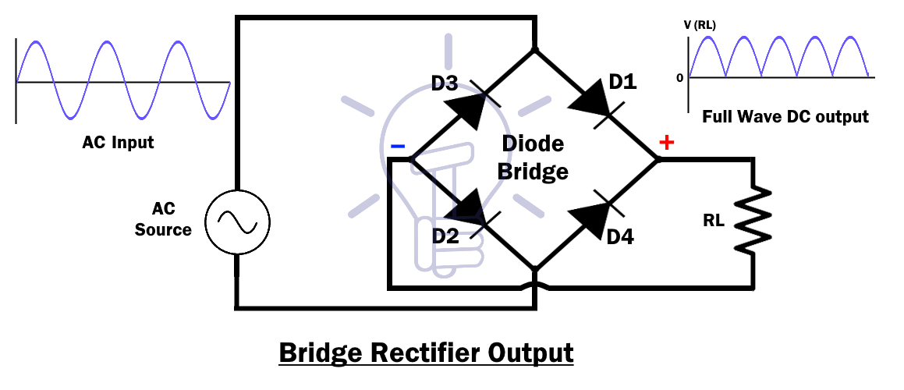

Figure 1. bridge rectifier output.

**Capacitors:**

There are three main passive circuit elements in any electrical circuities, these main elements are resistance, inductor, and capacitor, all of the previous elements limit the flow of the current input, but each has a different way. The capacitor resists change in voltage and can store energy when the voltage is steady. Capacitors are made of two inductors separated by an insulating layer. Therefore, the main job of a capacitor is to store energy [5].

**Transformers:**

Transformers is an electrical device made of laminated steel core and two isolated coil wires. The main job of a transformer is to transfer the flow of a current from one circuit to another. When the alternating current with a certain frequency enters either of the coils, an output of an alternating voltage with the same frequency flows from the other coil. The coil connected to the alternating voltage is called the primary coil (primary winding), and the other coil which is connected with the alternating current is called the secondary coil (secondary winding) [6](see fig.2).

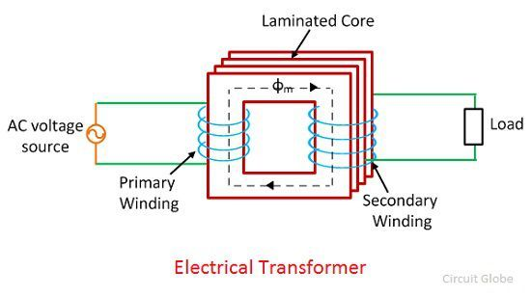

Figure 2. Electrical Transformer.

**Integrated Circuits and Voltage Regulators:**

Integrated circuit (IC) is millions of electronic devices that work together at the same time while using a series of complex steps, then grouped together on a chip to perform a certain function [7]. Voltage regulators is an integrated circuit, Voltage regulators main job is to output a staple DC voltage and to maintain its stability, regardless of a change in the input voltage or the load [8]. Voltage regulator (78xx) output a positive voltage, while (79xx) voltage regulators output a negative current.

Practical Installation

The next table shows the component used in this project’s circuit along with the quantities and values of the component:

|  |  |  |  |  |
| --- | --- | --- | --- | --- |
| Name | Physical Shape | Symbol | Value | Quantity |
| Voltage regulator | 12V Voltage Regulator - LM7812 - 2 Pack | LM7812 and decoupling capacitor value - Electrical Engineering Stack  Exchange | LM7812 | 1 |
| Voltage regulator | LM7805 7508 Positive Voltage Regulator IC, 5V 1A (Set Of 5) at Rs 45/pack |  Airport | Varanasi| ID: 19531408530 | 7805 Voltage Regulator IC Pin Diagram & Schematics | LM7805 | 1 |
| Diode  Bridge | 10PCS KBU810 8A 1000V diode bridge rectifier power diode electronica  componentes voltage rectifier KBU-810 - buy from 5$ on Joom e-commerce  platform | bridge rectifier Cheaper Than Retail Price> Buy Clothing, Accessories and  lifestyle products for women & men - | 2A | 1 |
| Copastor | Capacitor 100 pf | Makers Electronics | Capacitor Symbol HD Stock Images | Shutterstock | 100n | 3 |
| Copastor | Electrolytic Capacitors - 220uF/25V | Faranux Electronics | Capacitor Symbol HD Stock Images | Shutterstock | 220uf | 1 |
| Transformer | 12V 2A Full-wave Transformer - Senith Electronics | Know Your Transformers | Hi-Fi News | 2A | 1 |

8

12

11

Figure 3. 5v and 12v circuit schematics.

10

9

7

6

5

4

3

2

1

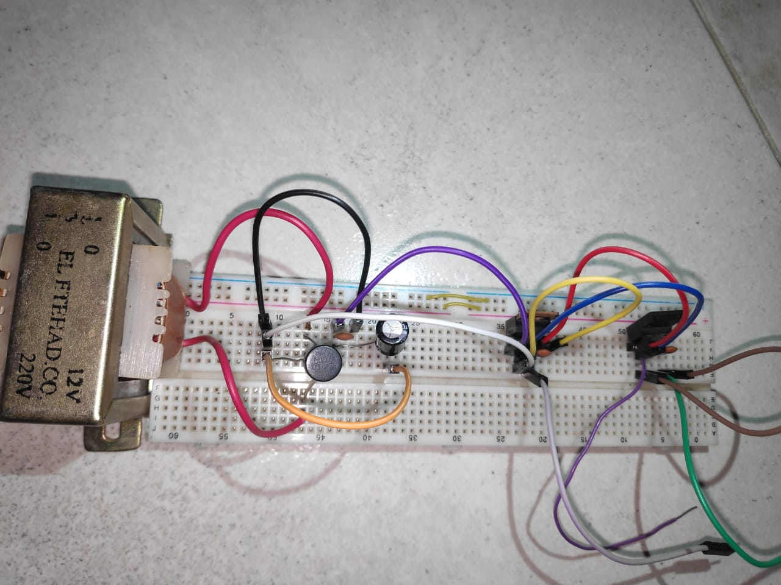

6

2

5

9

10

7

4

3

Figure 4. the physical circuit on the breadboard with parts number.

**Parts description:**

1- AC voltage source.

2- 2A transformer: transfer the ac current from the voltage source to the circuit.

3- 2A diode bridge: allow one direction for the current to flow, therefore transferring the AC current to a DC.

4- 220uf capacitor: store energy.

5- 100n capacitor: store energy.

6- voltage regulator: LM7812 outputs a positive 5v voltage.

7- 100n capacitor: store energy.

8- 5v output.

9- voltage regulator: LM7805 outputs a positive 12v voltage.

10- 100n capacitor: store energy.

11- ground.

12- 12v output.

Results

Figure 7. 12v output.

Figure 6. 5v output.

Figure 5. circuit on the breadboard.



This circuit outputs two currents, the first is 5v and the second is 12v. this circuit is useful when when we need two DC voltages for the operation of a circuit, so it is used in computers, welding, aircraft, automation, medical, and electric vehicles.

References

[1]M. Brown, “power supply cookbook”, p71, 2001, [www.EDN.com](https://books.google.com.eg/books?hl=en&lr=&id=zWcpOJNz7n8C&oi=fnd&pg=PP1&dq=power+supply&ots=CxfSEqZkXO&sig=t1U76mZfJ3Zb_fJHdRIpKLG0ArU&redir_esc=y#v=onepage&q=power%20supply&f=false)

[2]E. Bonizzoin, F. Borghetti, and P. Malcovati. “A 200-mA, 93% peak power efficiency, single-inductor, dual-output DC–DC buck converter”. *Analog Integr Circ Sig Process* 62. 2010. <https://link.springer.com/article/10.1007/s10470-009-9330-x>

[3]S. Shahjahan. “12v and 5v Dual Power Supply” *Circuits DIY, 2021,* [*https://circuits-diy.com/12v-5v-dual-power-supply/*](https://circuits-diy.com/12v-5v-dual-power-supply/)

[4]EZphd, “Basic Electrical and DC Theory”, *DOE Fundamentals Handbook,* vol.1, chap.1, pp.10, chap 2, pp.5 , June 1992, <https://d6s74no67skb0.cloudfront.net/course-material/EE601-Basic-Electrical-and-DC-Theory.pdf>

[5] R. P. Deshpande. “Capacitors” *McGraw-Hill Education,* pp.3, 2015. <https://www.accessengineeringlibrary.com/content/book/9780071848565>

[6]R. Lee, “Electronic Transformers and Circuits”, *Jhon Willy & Sons,* pp.1, 1955, <https://www.pearlhifi.com/06_Lit_Archive/02_PEARL_Arch/Vol_16/Sec_51/4455_Electronic_Transformers_and_Circuits.pdf>

[7] C. H. Stapper, F. M. Armstrong and K. Saji, "Integrated circuit yield statistics," in *Proceedings of the IEEE*, vol. 71, no. 4, pp. 453-470, April 1983, <https://ieeexplore.ieee.org/abstract/document/1456887>

[8]J. Spencer, D. Pippenger, “the voltage regulator handbook”, *Texas Instruments,* pp.1*,*1977, <https://frank.pocnet.net/other/sos/TexasInstruments_TheVoltageRegulatorHandbook_1977.pdf>

[9]F. Toich, “A SHORT HISTORY OF THE EVOLVED POWER SUPPLY”, *kepco currents,* vol.7, no.1, <https://www.kepcopower.com/newsevo.htm#:~:text=The%20power%20supply%20industry%20dates,a%20built%2Din%20power%20supply>.